Lab 1

In this lab students will be divided into the groups of three.
The main objective of this lab is to get the students familiarize with the working in the team and how to work in collaboration. Please read the complete lab before starting it.
In this Lab we have to create a C++ dll that can perform the following Matrix Operations
Add a Matrix
Subtract a Matrix
Multiply a Matrix
Write down a Test client program that can use this dll.
Students will download the Skeleton project from the github and then work on project.
There will be three cpp files in the dll where each student will write its own part and will push it on the repository and then also merge the common part together.
Please follow the steps as mentioned below.

- Go to the Web Site https://github.com/
- Create your account at github.com
- Download Desktop client from github.com
- Install the Client Application
- Login with your account
- Find the repository by searching softwareconstructioncourse/matrixclient on website

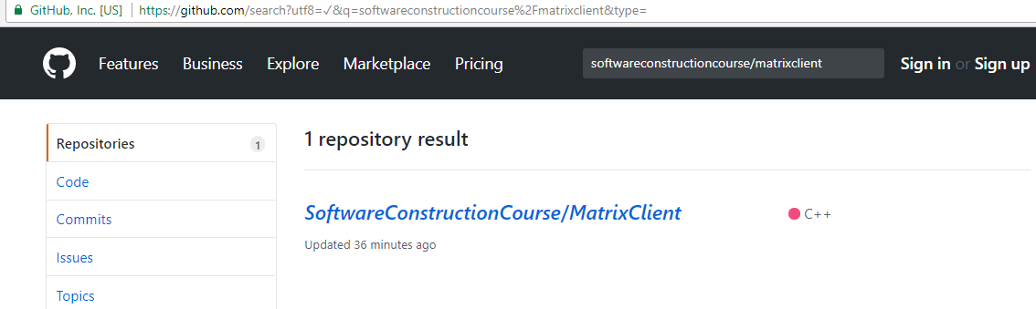

- Click on the search result returned and on the next screen press the clone download button.
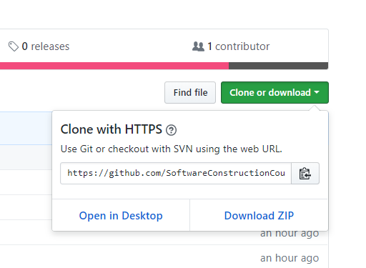
- Copy WebURL
- Open the Desktop client .Go to File –> Clone Repository
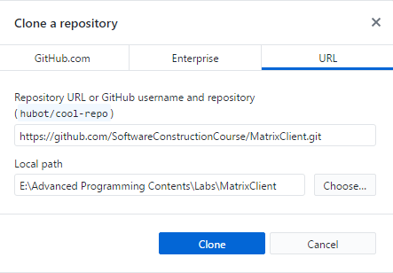

Enter the URL as posted above. https://github.com/SoftwareConstructionCourse/MatrixClient.git
Select the Local path where you want to save the project and clone.
Once its downloaded please divide the work as follows
- Team member 1 will implement the Matrix Addition and Subtraction
- Team member 2 will implement the Matrix Multiplication
- Team member 3 will implement the Matrix Transpose.
- Team members will implement the Clinet application that can use the dll.

Once every members have done its part. Now is the time to merge the code.
Ask your team lead to create its own repository on git hub
Initialize the repository.
Each member will push its changes on the repository.
The members will download the working code for the TA and then will show the working program.

